**PACKAGE MANAGEMENT – YUM**

**What is YUM?**

* YUM - Yellowdog Updater Modified
* YUM is an open-source command-line as well as graphical-based package management tool for RPM (RedHat Package Manager) based Linux systems.
* It allows users and system administrators to easily install, update, remove or search software packages on a system.

**Install a Package with YUM:**

* yum install zip
* dnf install zip

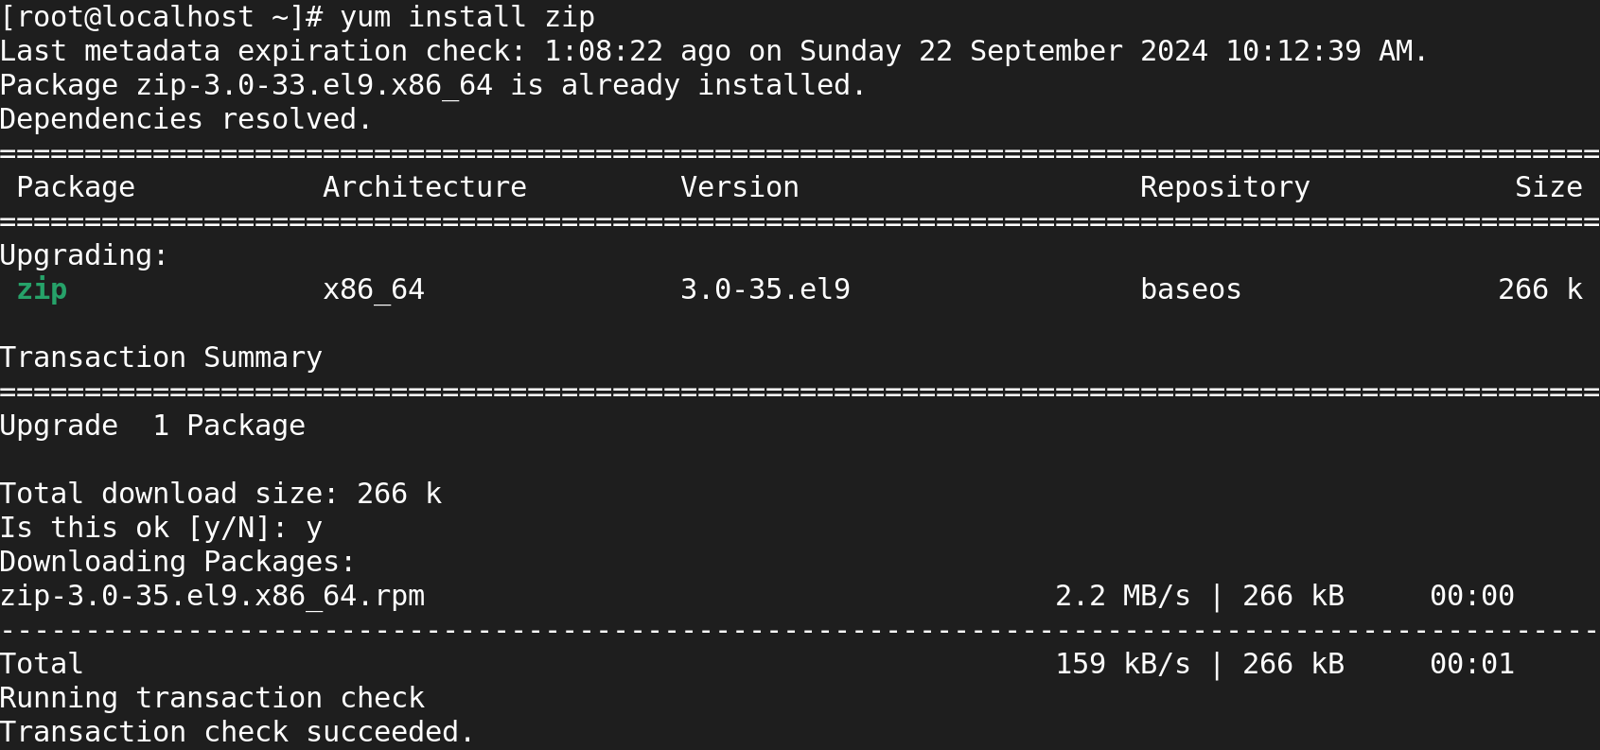

**Removing a Package with YUM:**

* yum remove zip

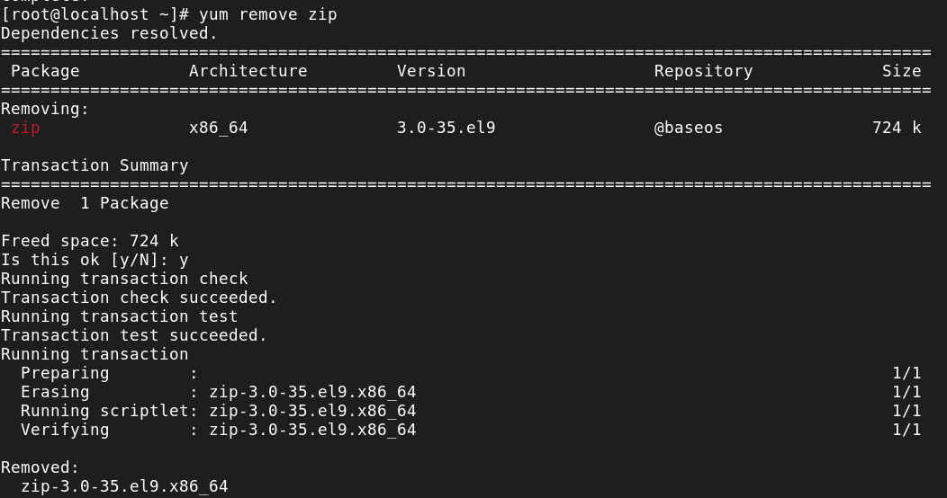

**Updating a Package using YUM:**

* yum update yum

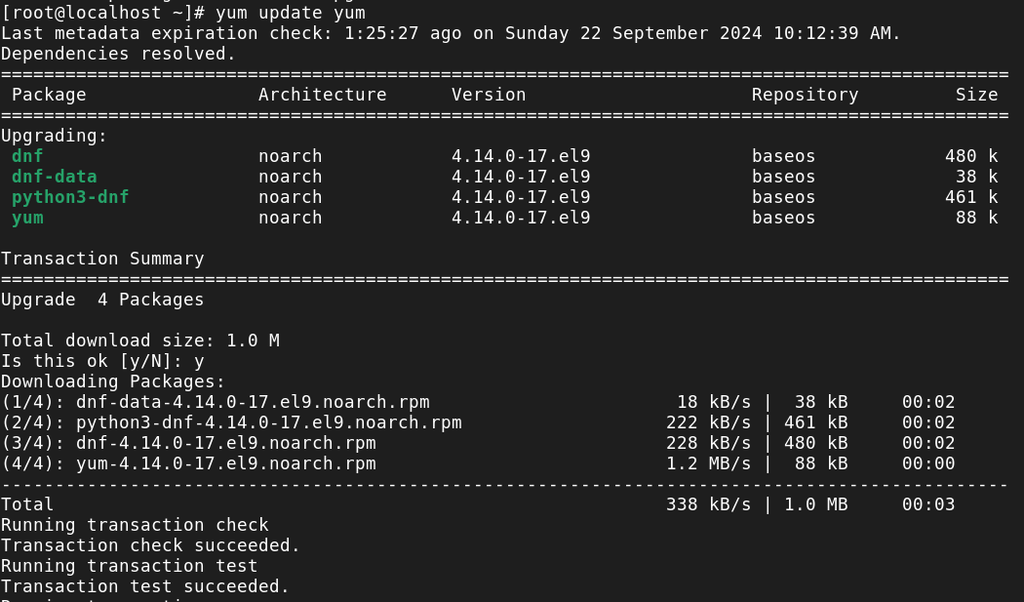

**List a Package using YUM:**

* yum list zip



**Search for a Package using YUM:**

* yum search coreutils

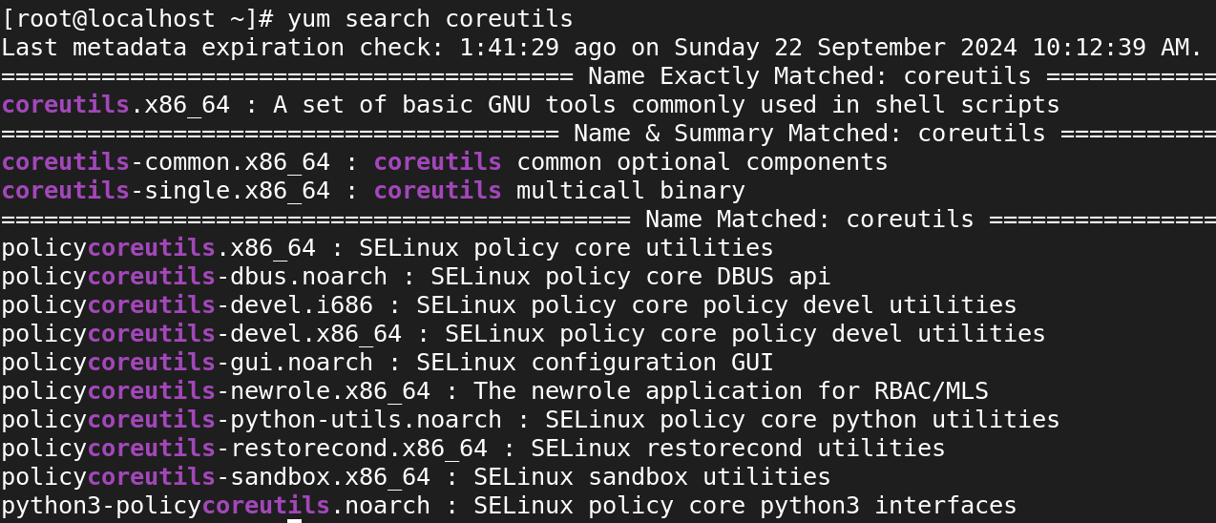

**Get Information about a Package using YUM:**

* yum info

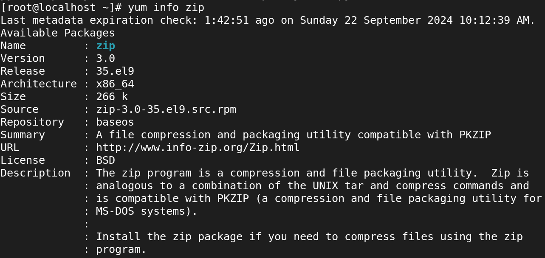

**List all Available Packages using YUM:**

* yum list | less

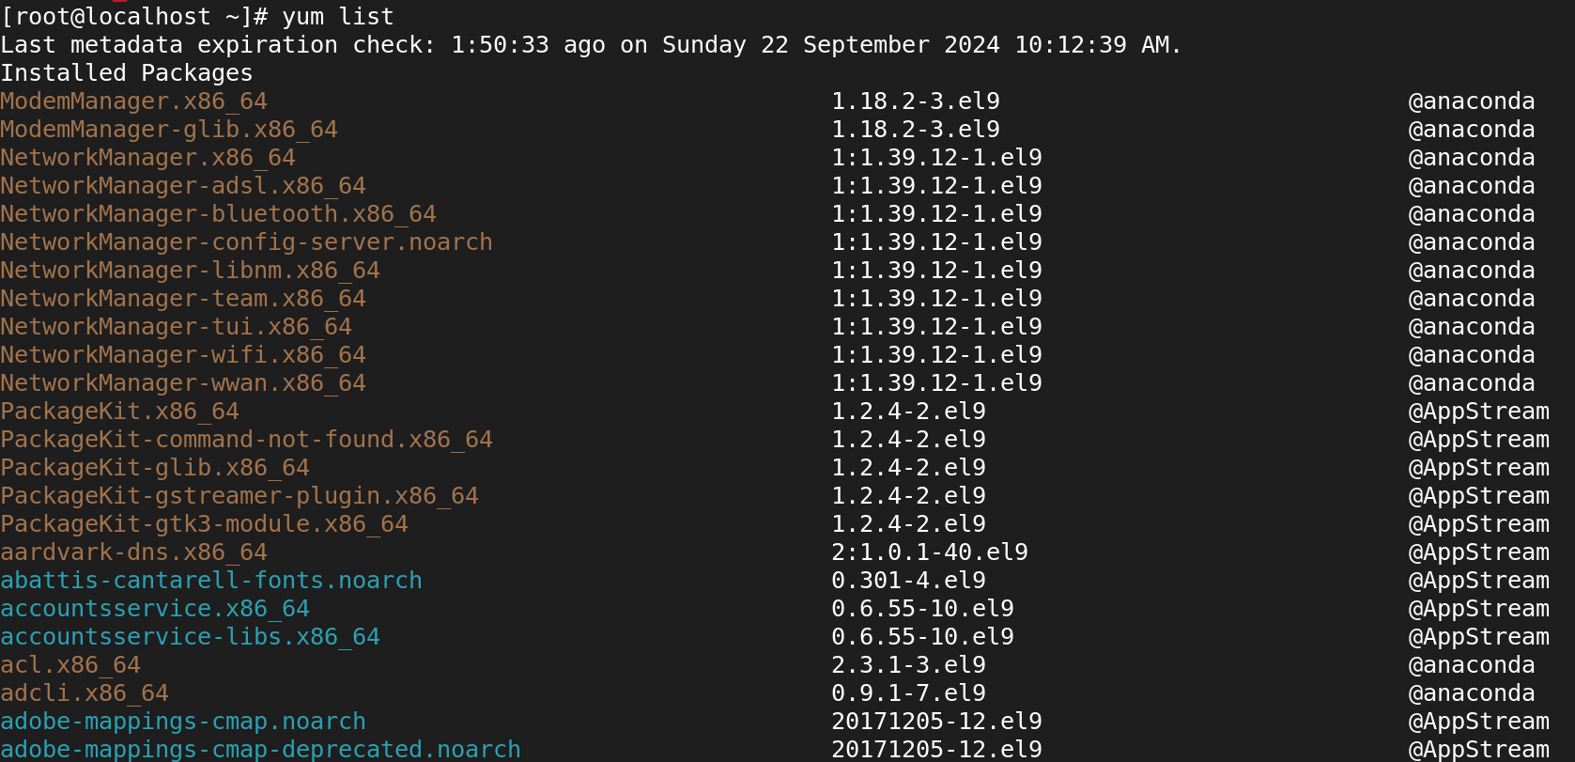

**List all Installed Packages using YUM:**

* yum list installed | less

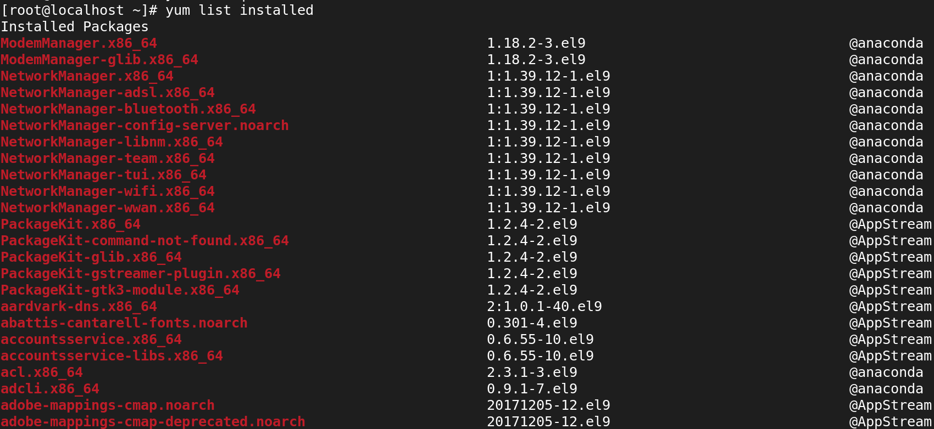

**Yum Provides Function:**

* yum provides mkdir

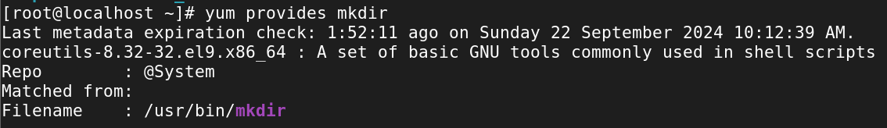

**Check for Available Updates using Yum:**

* yum check-update

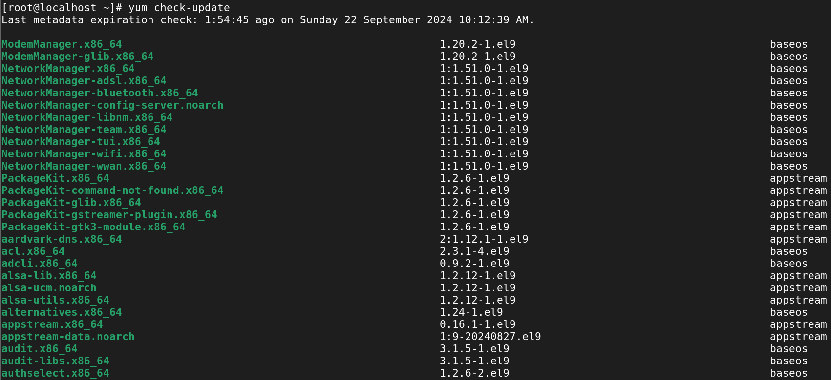

**Update System using Yum:**

* yum update

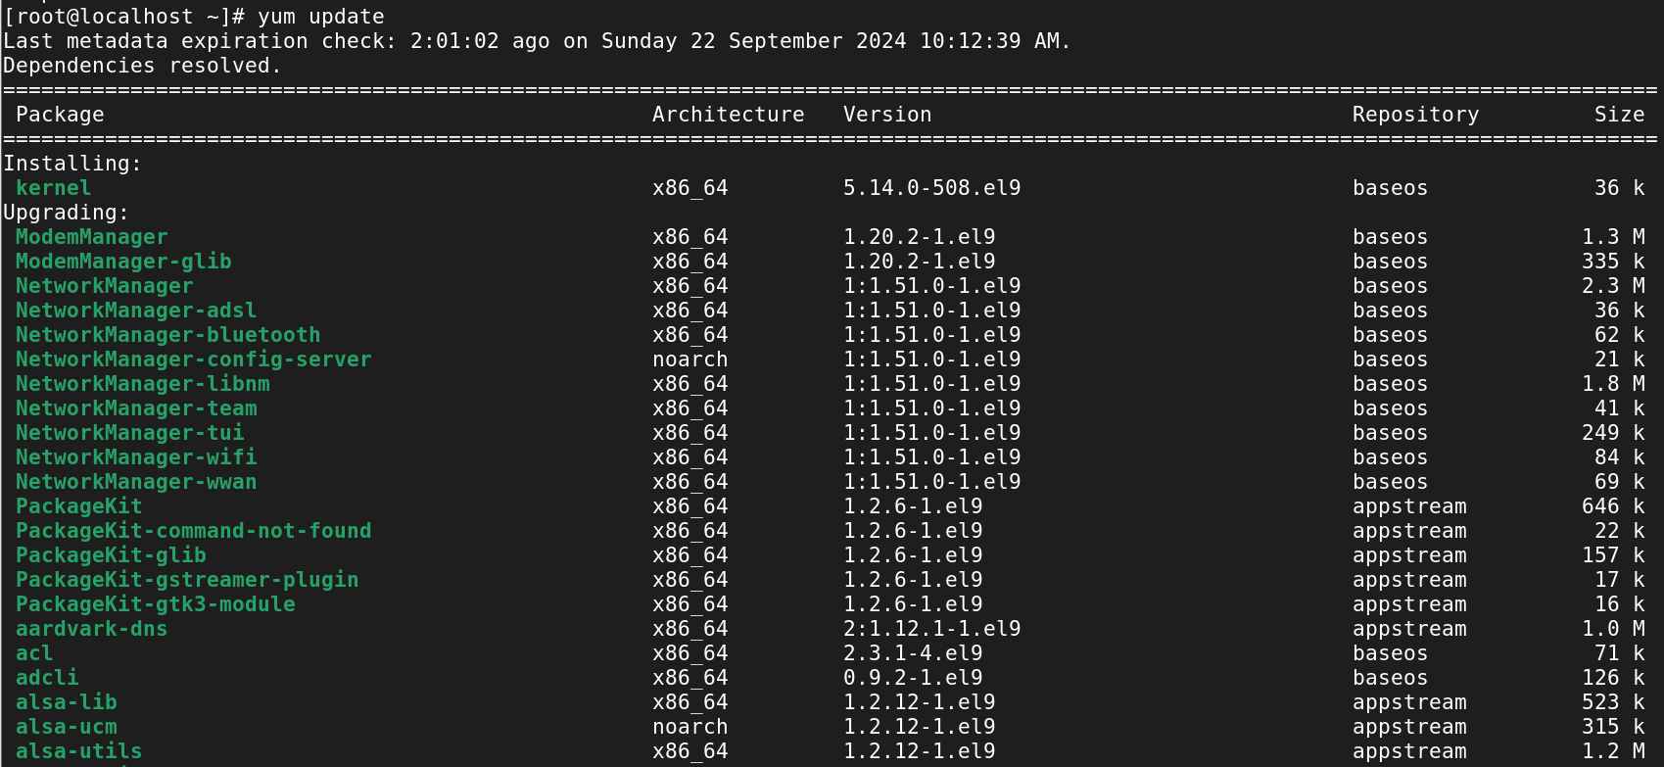

**List Enabled Yum Repositories:**

* yum repolist

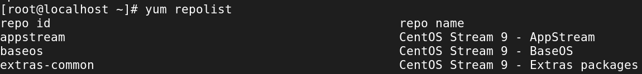

**List all Enabled and Disabled Yum Repositories:**

* yum repolist all

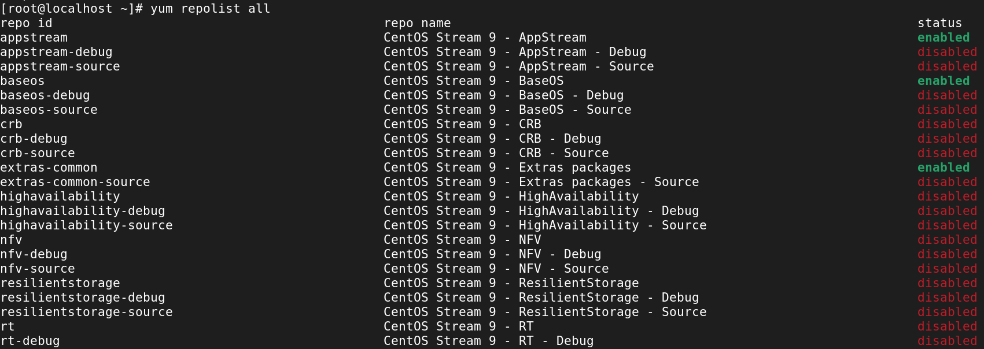

**Clean Yum Cache:**

* yum clean all



**View History of Yum:**

* yum history

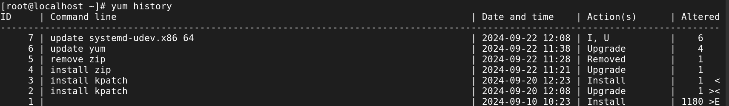

**UNDO:**

* yum history undo 3

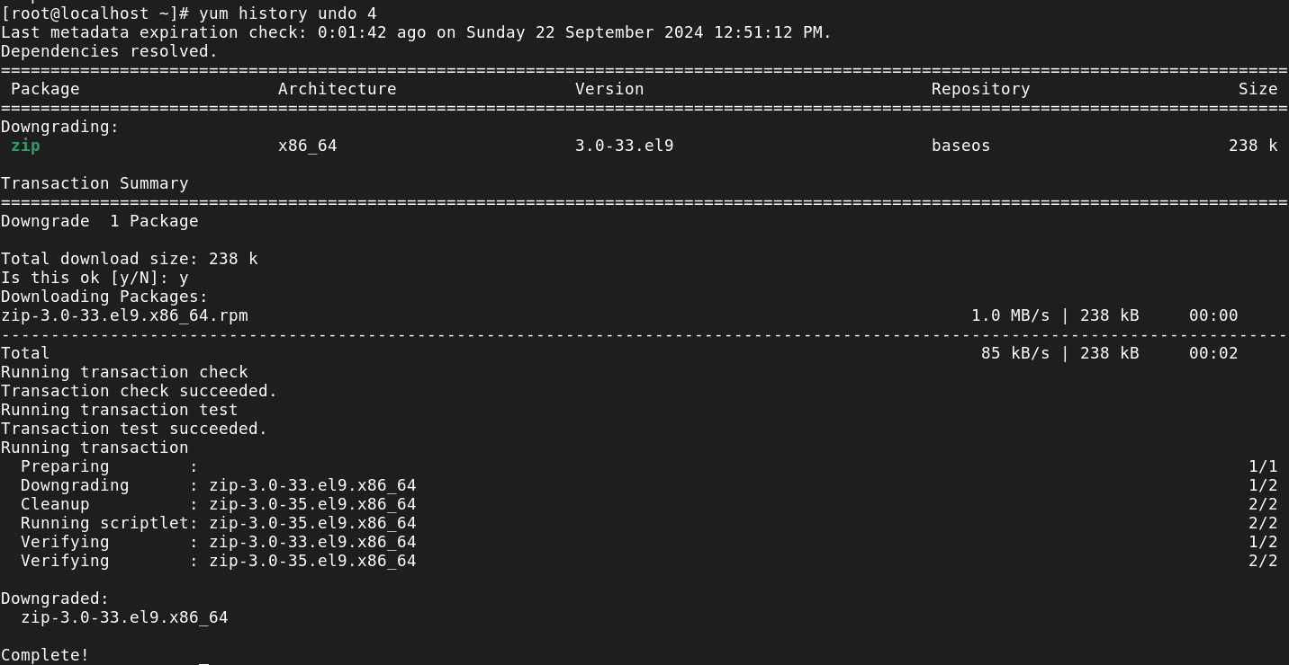

**REDO:**

* yum history redo 4

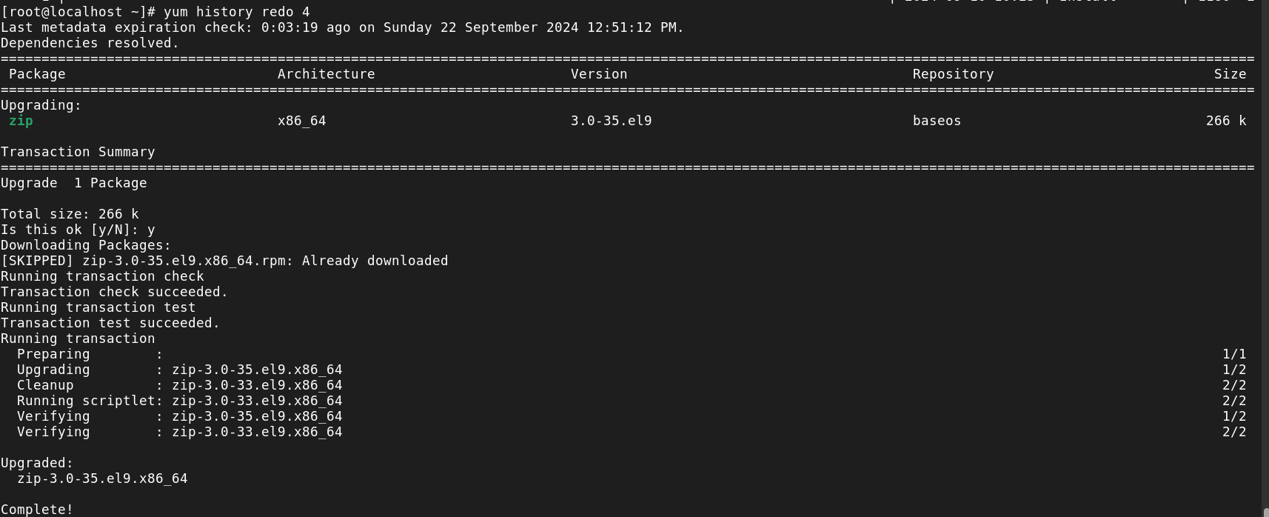

**Enable repository:**

* yum-config-manager –enable appstream-debug

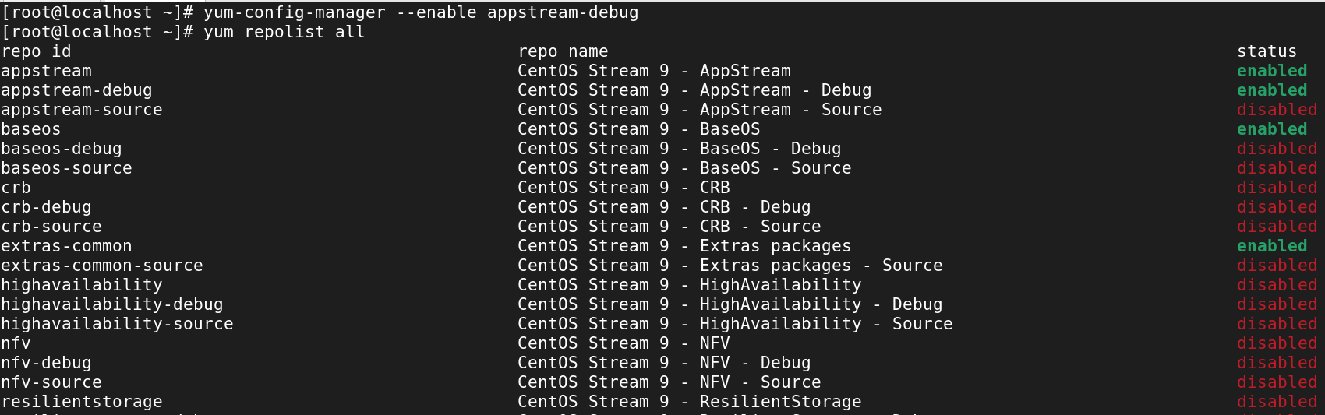

**Disable repository:**

* yum-config-manager –disable appstream-debug

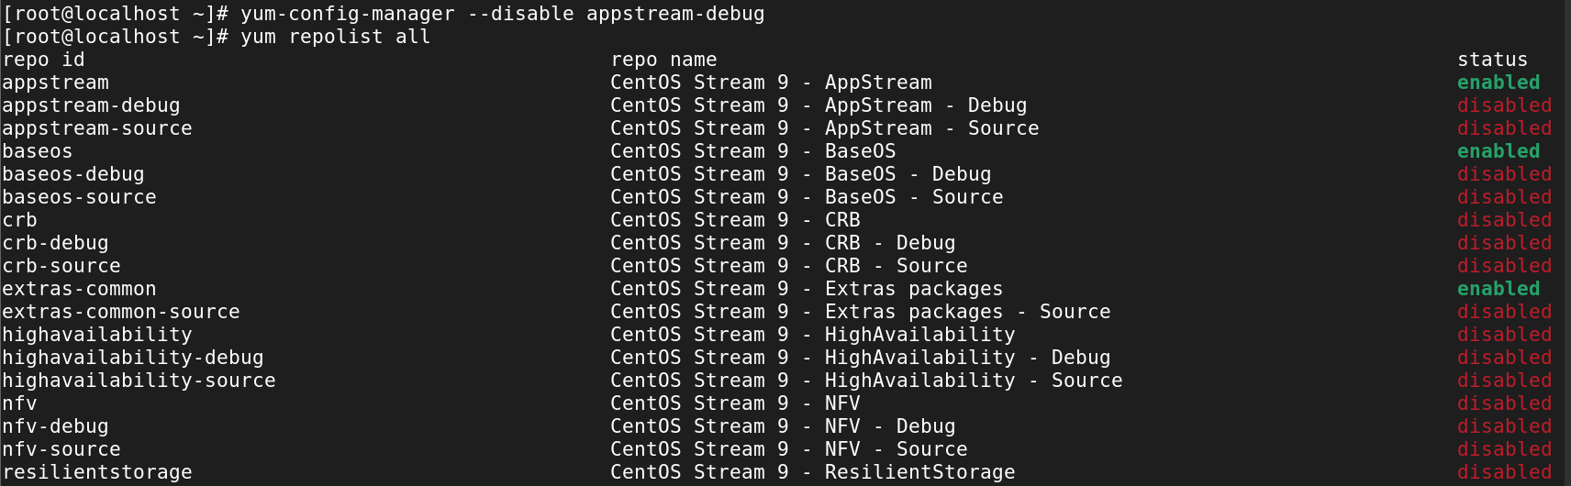

**Install a Package from a Specific Repository:**

* yum –enablerepo=highavailability install pacemaker

